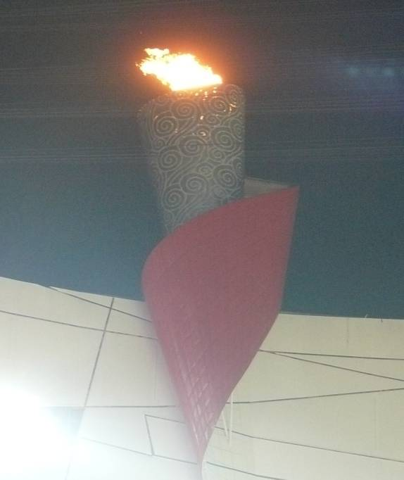
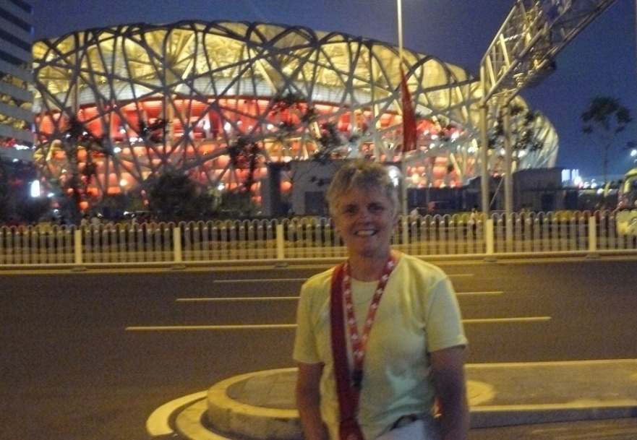
Judy at China’s National Stadium “the Bird’s Nest”, Beijing
The Olympic Flame, Beijing
All Roads Lead to Beijing 2008
My journey with the Women’s National Soccer Team began in May 2007 with an invitation to join them at a training camp in Auckland, New Zealand. Since that time the team has travelled far and wide in preparation for a place at the Olympics in Beijing. I have had the privilege of providing physiotherapy skills for this incredible group of dedicated young athletes at several exciting places and events. These included a training camp in Singapore and Tokyo, Japan before the World Cup in Hangzhou and Chengdu, China. We were then invited to Guangzhou, China for the Four Nations Cup. We won the Cyprus Cup in Larnaca, Cyprus and enjoyed a side trip to Paris on the way home to play a friendly game against the Women’s National team of France. Qualifying for the Olympics in Juarez, Mexico was thrilling. The Queen’s Peace Cup Tournament in Suwan, Korea was a fabulous test for the team before returning to China for the tournament of their careers. We played in Tianjin, Shanghi and Beijing, during the Olympic Games in August. Each place and event provided its own share of excitement and challenges. When not travelling, we worked together during their residential camp in Vancouver. All of this could not have been possible without the unfailing support of my colleagues and administrative staff at the Jericho. A mere thank you does not begin to express my appreciation.
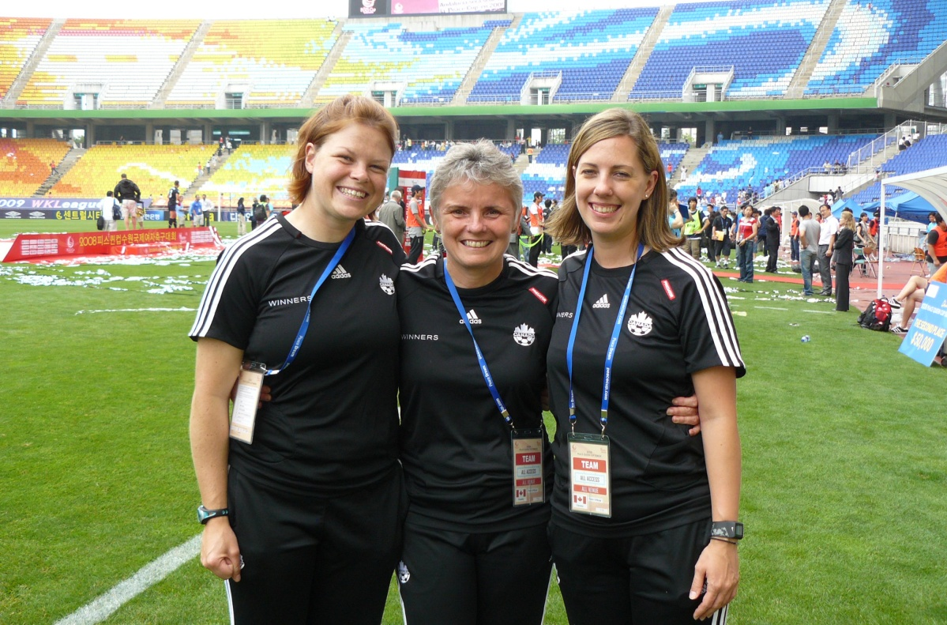
Becky Swan CATA, Judy Russell RPT, Nicole Stephen RMT Peace Cup, Korea
Nicole Stephen, Registered Massage Therapist (www.everesttherapeutics.com) and Certified Athletic Therapist Becky Swan (www.activfit.ca), both from Vancouver rounded out the medical team for the majority of these trips and provided a vital service as we lightened each other’s loads. It was a pleasure working with these talented practitioners, exchanging ideas and opinions on a daily basis. When energy and time allowed, we provided in-services for each other, teaching about a new tape support or massage technique or assessment tool so that we each might be better prepared to help our athletes.
We had a physician accompany us on the majority of our trips. However, on the one major trip we didn’t have a physician, we had one of our coaches hospitalized with an undiagnosed ailment, two athletes taken to emergency for x-rays and another athlete cut for stitches on her scalp after knocking heads with an opponent at the goal mouth. These injuries presented challenges to us and required all of our first responder skills. The inimitable Dr. Andrew Pipe from Ottawa joined our team for the Olympic experience as did Surrey Chiropractor Garret Kusch and Burnaby Physiotherapist Marc Rizzardo. All three added their own welcomed expertise.
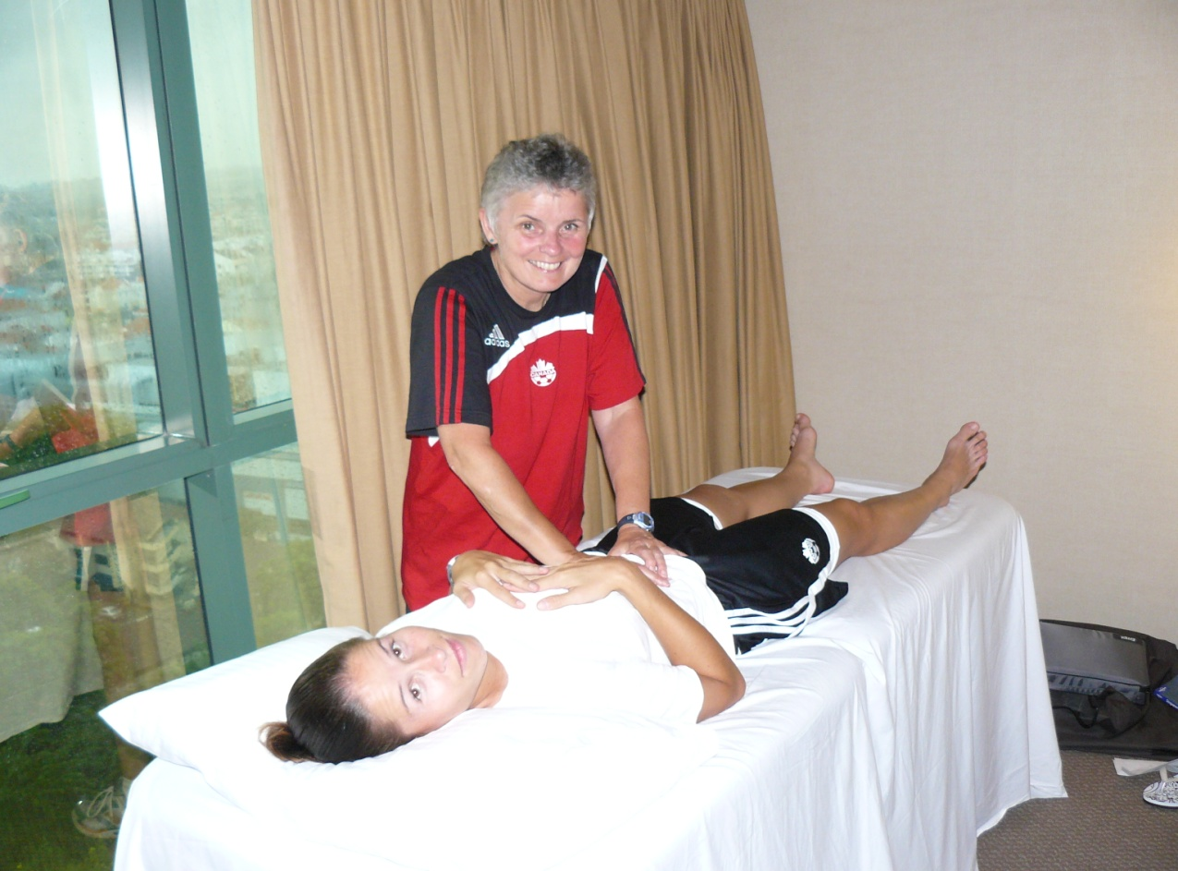
Judy with defender Kristina Kiss in Tokyo, Japan
Over the course of 15 months, hamstring strains were the most common injuries we treated. These were complicated by pelvis imbalances and lumbar spine malalignments. Anterior cruciate injuries ran a very close second. We also dealt with two acromio-clavicular second degree sprains and the odd broken nose. High ankle sprains, foot problems, stress fractures and minor/major concussions also added to the long list of injuries we sustained and rebounded from with the assistance of a tremendous support team at the Sports Medicine Council of BC, a collection of dedicated surgeons, physicians, nutritionists, sports psychologists, physiologists, physiotherapists, chiropractors, massage therapists and strength and conditioning staff. All the manual therapy tools (including Visceral Manipulation and Cranio-Sacral Therapy) came out of the kit bag to help keep the players in the game.
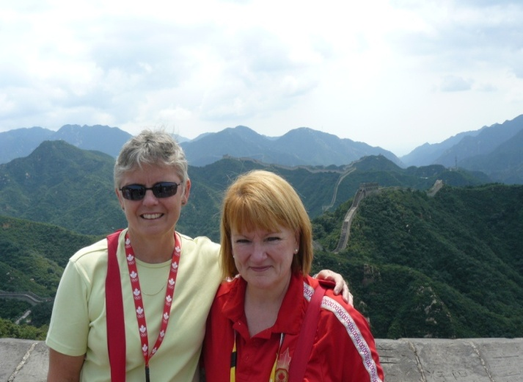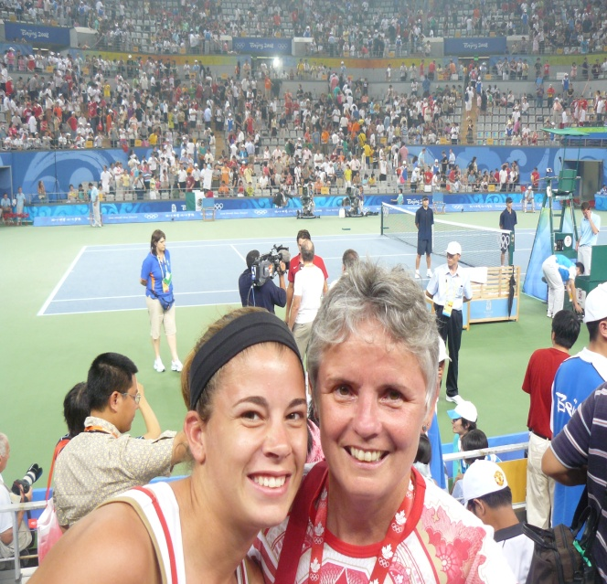
At the Great Wall with Maeve Glass At Centre Court with Keeper -Steph Labbe
It wasn’t all work and no play. Trips to the Great Wall or Tiananmen Square or the Pearl Market for that matter were not to be missed. For me the highlights of the Olympic Games, other than working with these incredible young women and a group of dedicated coaching and support staff, included Simon Whitfield’s come from behind Silver Medal in the Triathalon, Roger Federer’s serve, Russia’s female pole vaulter breaking her own world record, Michael Phelp’s eight gold medals, Canadian Carolyn Huynh’s gold medal in wrestling and Adam Van Koeverden’s gutsy silver medal performance.
Our own Christine Sinclair’s final bullet goal against the USA to tie our quarter final game in regulation time was breathtaking. Our team played their hearts out. Unfortunately, despite their best efforts, the Canadian Women’s Soccer Team lost in double overtime (2-1) to the eventual gold medal USA Team. The players will always be champions to me. It was not the end of their Olympic experience as many stayed on to attend other sports events and walk in during the unforgettable closing ceremonies.
China put on an Olympics that defies definition, the likes of which we will not see again. The facilities were outstanding, the people generous and the competition beyond all expectations. Thanks for the memories. I would do it all again in a heartbeat.
Sincerely,

Judy Russell B.A., B.Sc., MCPA
www.jerichophysio.com

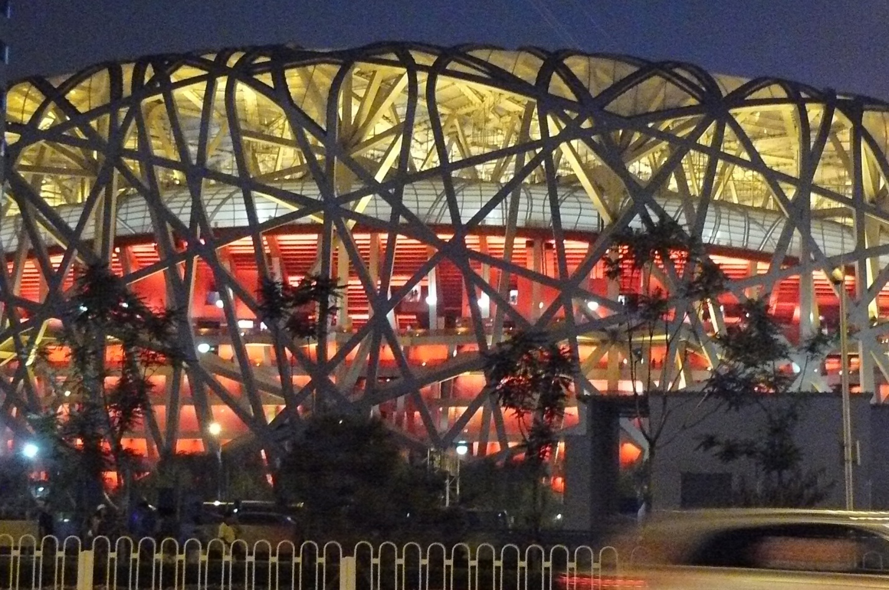
China’s National Stadium “The Bird’s Nest” 2008 Olympic Games Beijing

